**Assignment 4**

**1. Create a stored procedure in the Northwind database that will calculate the average value of Freight for a specified customer.Then, a business rule will be added that will be triggered before every Update and Insert command in the Orders controller,and will use the stored procedure to verify that the Freight does not exceed the average freight. If it does, a message will be displayed and the command will be cancelled.**

alter PROCEDURE que1

AS

SELECT CustomerID, AVG(Freight) as AvgFreight

FROM Orders

GROUP BY CustomerID

GO

insert into orders values ( 'ALFKI', 1,'1997-08-25 00:00:00.000', '1997-08-01 00:00:00.000','1997-01-01 00:00:00.000', 1,80, 'Wolski Zajazd', 'ul. Filtrowa 68',

'Warszawa', 'Tachira', 24100, 'brazil')

exec que1

UPDATE Orders SET Freight=100 WHERE OrderID = 10248

SELECT * FROM Orders WHERE OrderID = 10248

create TRIGGER tr_que1_update

ON orders

INSTEAD OF UPDATE

AS

BEGIN

Declare @OrderID int

Declare @CustomerID varchar(50)

Declare @Freight money

Declare @AvgFreight money

Declare @t_ave TABLE(CustomerID nchar(5), AvgFreight money)

INSERT @t_ave

exec que1

Select * Into #Temptable FROM Inserted

While(Exists(Select OrderID from #TempTable))

Begin

Select TOP 1 @OrderID = OrderID, @CustomerID = CustomerID, @Freight=Freight

FROM #Temptable

SET @AvgFreight = (SELECT AvgFreight FROM @t_ave WHERE CustomerID = @CustomerID)

Print @Freight

Print @AvgFreight

IF @Freight > @AvgFreight

BEGIN

RAISERROR ('ABOVE AVERAGE',16,1)

END

ELSE

BEGIN

UPDATE Orders SET Freight = @Freight WHERE OrderID=@OrderID

END

Delete from #TempTable where OrderID = @OrderID

End

END

alter TRIGGER tr_que1_insert

ON orders

INSTEAD OF INSERT

AS

BEGIN

Declare @OrderID int

Declare @CustomerID varchar(50)

Declare @Freight money

Declare @AvgFreight money

Declare @t_ave TABLE(CustomerID nchar(5), AvgFreight money)

INSERT @t_ave

exec que1

Select * Into #Temptable FROM Inserted

While(Exists(Select OrderID from #TempTable))

Begin

Select TOP 1 @OrderID = OrderID, @CustomerID = CustomerID, @Freight=Freight

FROM #Temptable

SET @AvgFreight = (SELECT AvgFreight FROM @t_ave WHERE CustomerID = @CustomerID)

IF @Freight > @AvgFreight

BEGIN

RAISERROR ('ABOVE AVERAGE',16,1)

END

ELSE

BEGIN

INSERT INTO Orders (CustomerID,EmployeeID,OrderDate,RequiredDate,ShippedDate,ShipVia,Freight,ShipName,ShipAddress,ShipCity,ShipRegion,ShipPostalCode,ShipCountry)

SELECT CustomerID,EmployeeID,OrderDate,RequiredDate,ShippedDate,ShipVia,Freight,ShipName,ShipAddress,ShipCity,ShipRegion,ShipPostalCode,ShipCountry

From Inserted

END

Delete from #TempTable where OrderID = @OrderID

End

END

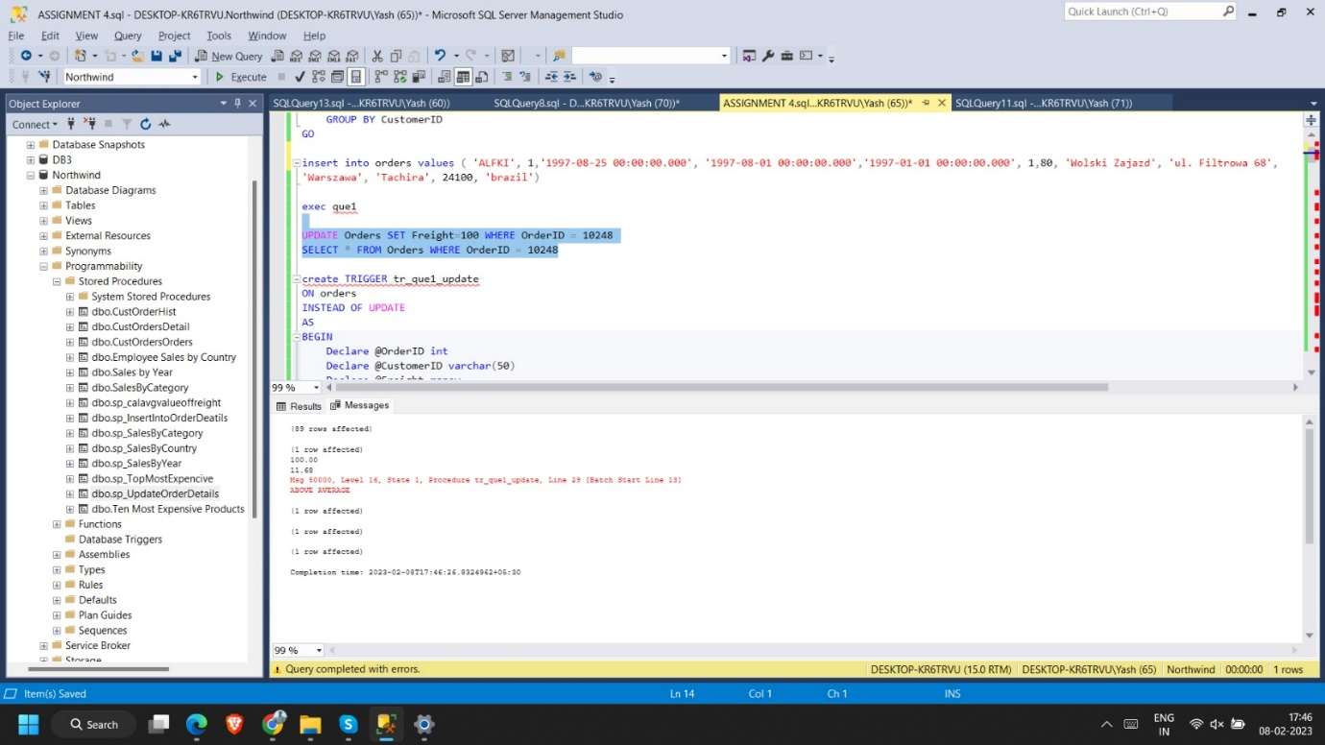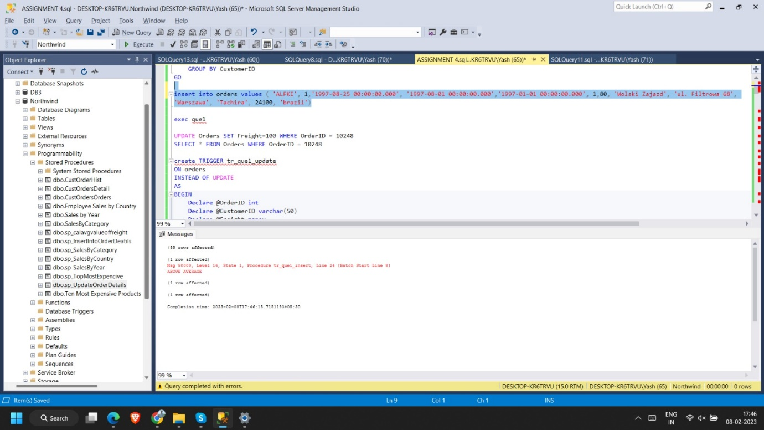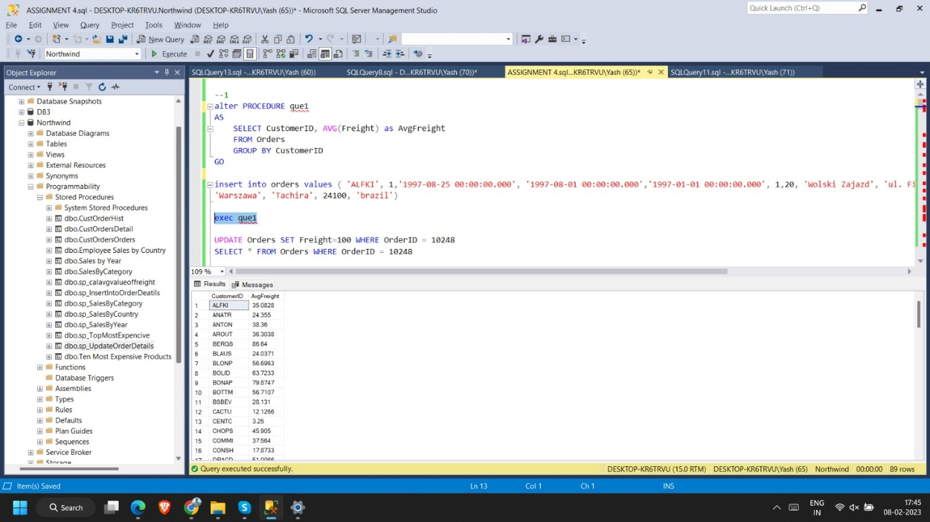

**2. write a SQL query to Create Stored procedure in the Northwind database to retrieve Employee Sales by Country**

alter procedure sp_SalesByCountry

@Employeename varchar(20)

as

begin

select e.EmployeeID,o.ShipCountry,count(o.OrderID) as [Total Orders]

from Employees e inner join Orders o on e.EmployeeID = o.EmployeeID

where e.FirstName = @Employeename

group by o.ShipCountry,e.EmployeeID

end

exec sp_salesbyCountry @Employeename ='Nancy'

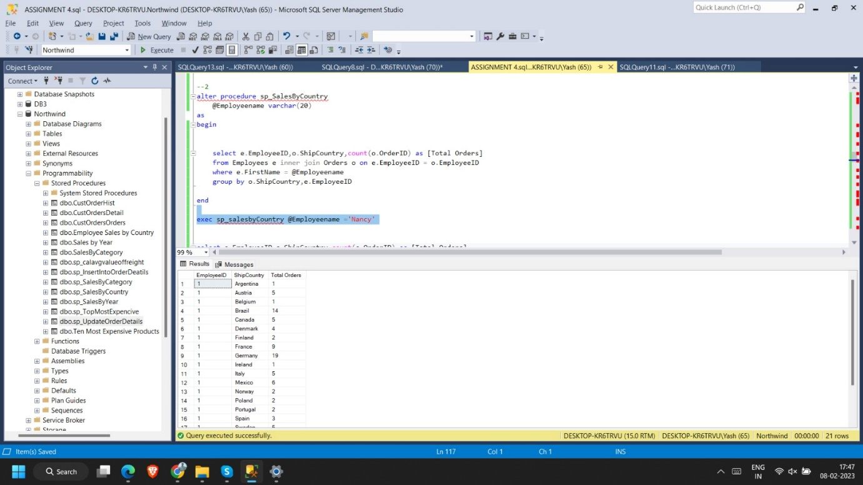

**3. write a SQL query to Create Stored procedure in the Northwind database to retrieve Sales by Year**

select year(OrderDate) as [year], count(OrderID) as [Total Orders] from Orders

group by year(OrderDate)

alter procedure sp_SalesByYear

@year int

as

begin

select year(OrderDate) as [year], count(OrderID) as [Total Orders] from Orders

where year(OrderDate) = @year

group by year(OrderDate)

end

exec sp_SalesByYear 1996

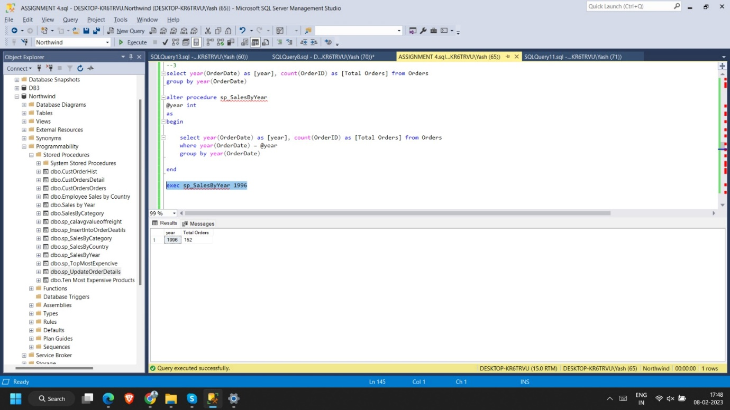

**4. write a SQL query to Create Stored procedure in the Northwind database to retrieve Sales By Category**

alter procedure sp_SalesByCategory

@CategoryID int

as

begin

select c.CategoryID, c.CategoryName, count(o.OrderID) as [Total Orders]

from Categories c inner join Products p on c.CategoryID = p.CategoryID

inner join [Order Details] o on p.ProductID = o.ProductID

where c.CategoryID = @CategoryID

group by c.CategoryID, c.CategoryName

end

exec sp_SalesByCategory 1

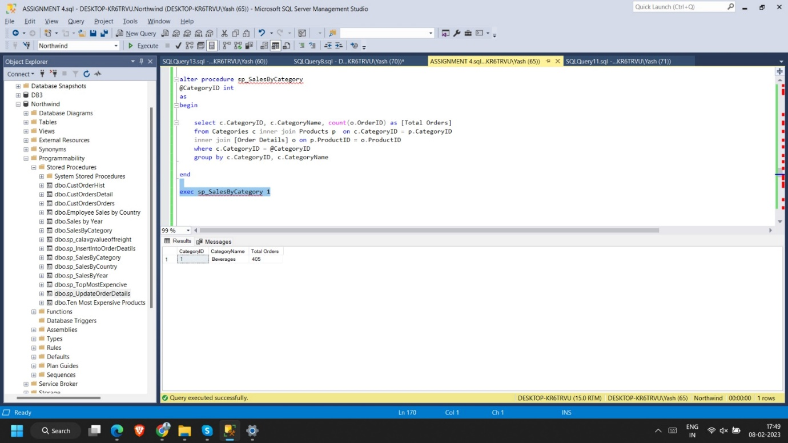

**5. write a SQL query to Create Stored procedure in the Northwind database to retrieve Ten Most Expensive Products**

alter procedure sp_TopMostExpencive

as

begin

select top 10 ProductName,UnitPrice from Products order by UnitPrice desc

end

exec sp_TopMostExpencive

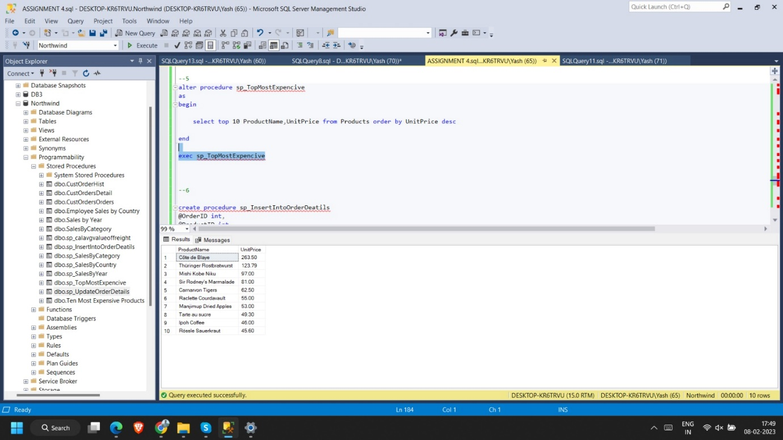

**6. write a SQL query to Create Stored procedure in the Northwind database to insert Customer Order Details**

alter procedure sp_InsertIntoOrderDeatils

@OrderID int,

@ProductID int,

@UnitPrice money,

@Quantity smallint,

@Discount real

as

begin

insert into [Order Details]

values(@OrderID,@ProductID,@UnitPrice,@Quantity,@Discount)

end

exec sp_InsertIntoOrderDeatils 10248,2,11.00,1,1.00

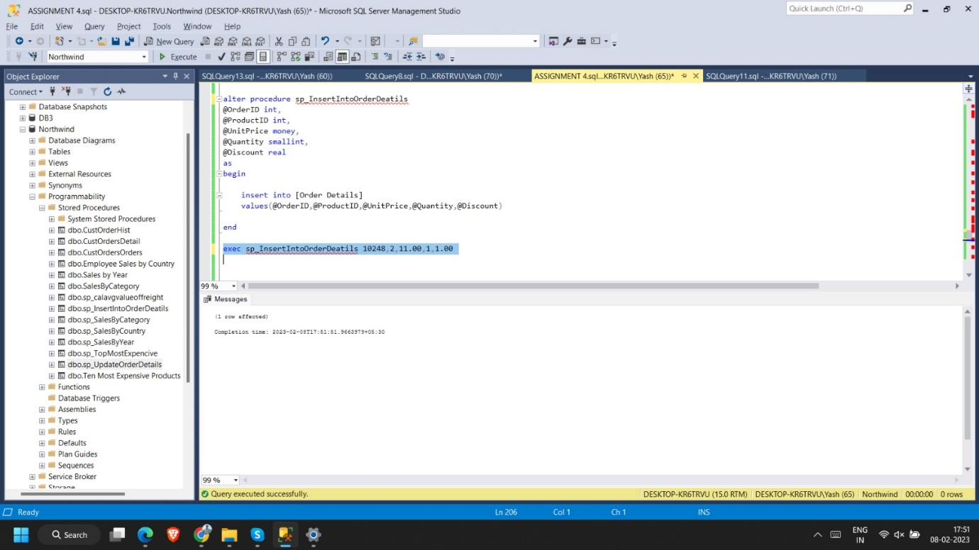

**7. write a SQL query to Create Stored procedure in the Northwind database to update Customer Order Details**

update [Order Details]

set UnitPrice=2, Quantity=2, Discount=0.5

where OrderID = 10248 and ProductID = 1

alter procedure sp_UpdateOrderDetails

@OrderID int,

@ProductID int,

@UnitPrice money,

@Quantity smallint,

@Discount real

as

begin

update [Order Details]

set UnitPrice=@UnitPrice, Quantity=@Quantity, Discount=@Discount

where OrderID = @OrderID and ProductID = @ProductID

end

exec sp_UpdateOrderDetails @OrderID=10248,@ProductID=1,@UnitPrice=22.00,@Quantity=2,@Discount=0.10

